Requirement Analysis Report

1. Introduction
   1. Purpose of the system
   2. Scope of the system
   3. Objectives and success criteria of the project
   4. Definitions, acronyms and abbreviations
   5. References
   6. Overview
2. Proposed System
   1. functional requirements
   2. Non-functional requirements
      1. usability
      2. Reliability
      3. Performance
      4. Supportability
      5. Implementation
      6. Interface
      7. Packaging
      8. Legal
   3. System models
      1. Scenarios
      2. Use case model
      3. Analysis object model
      4. Dynamic model
      5. User interface-navigational paths and screen mock-ups
3. Glossary
4. INTRODUCTION
   1. **Purpose of the system**

Document management software is a solution that handles documents creation, printing, sharing, organization and archiving. The solution streamlines these processes to improve the productivity of your business’ way of managing files digitally. Its central electronic location makes documents and information easy to find which saves your time so you can manage more of your company’s core operation.

* 1. **Scope of the system**

**Project goal:** To build a ready-to-implement document controller software.

**Project deliverables:**

1. Document storage.

2. Security and access control.

3. Version control.

4. Indexing and classification.

5. Bulk upload.

6. PDF document editor.

7. White-labelling.

8. File synchronization.

9. Audit trail.

10. Logs

10.1. User Logs (Software Admin will control)

10. 2. File Logs (DC will Control)

**Project deadline:** latest by December

* 1. **Objectives and success criteria of the project**

1. **Centralizing document management**. Having a DMS organizes your file easily using tags and labels.

2. **Increasing data security**.  The manager can grant them access and approve the actions they can do, such as viewing, editing, printing and sharing the document. Furthermore, you’ll know who made all modifications in the file’s history. Documents are also protected from disasters, fires, and floods because they are safely stored in the system.

3**. Expediting file retrieval.**  streamlining the process helps in speeding up archiving and finding lost files. Simply use a keyword or key phrase to look for a specific file.

4. **Bolstering regulatory compliance**. Doing this manually is challenging. However, the document management software makes it hassle-free using audit trails, security, and backups to ensure compliance.

5. **Reducing carbon footprint.**

* 1. References
     1. [www.financesonline.com](http://www.financesonline.com)
     2. [www.laserfiche.com](http://www.laserfiche.com)
     3. [www.app.pandadoc.com](http://www.app.pandadoc.com)

2.Proposed System

* 1. functional requirements
  2. System models
     1. Scenarios
     2. Use case model
     3. Analysis object model

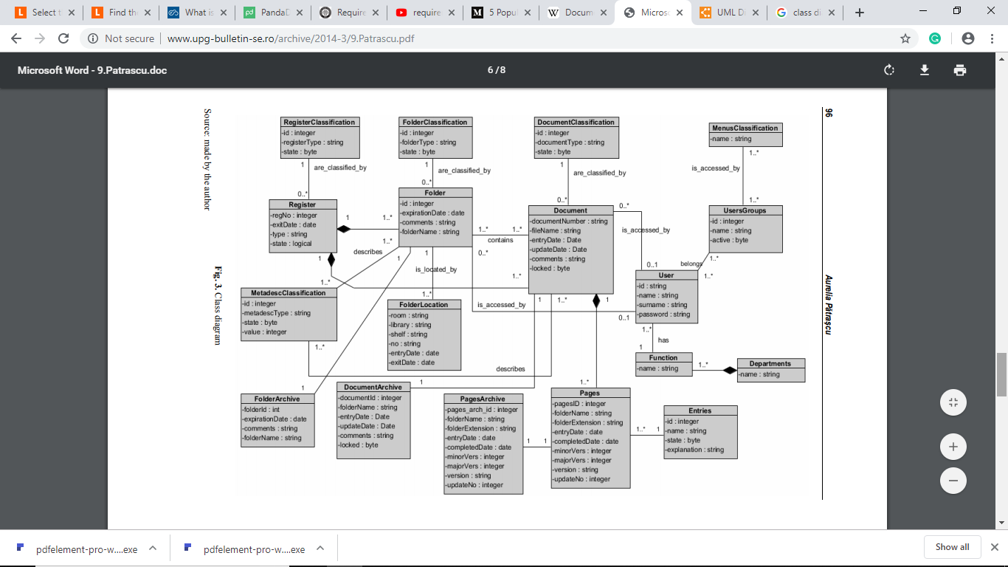

* + 1. Dynamic model
    2. User interface-navigational paths and screen mock-ups

1. Glossary